
How to add a custom library to MCUEXPRESSO
Advanced Embedded Systems

Authors: Dr. Gilberto Ochoa Ruiz
Msc. Jorge German Perez Blanco
Contents
Introduction 3
Adding a library that you have the source code 3
Adding a static library to your project 4
Example application 6
Annexes 7
Other Resources 7
Example application code 7
HCSR04.h 7
HCSR04.c 8
Main app code 11

Introduction
In the ever-evolving landscape of embedded systems, microcontroller units (MCUs) serve as the heartbeat of countless devices, ranging from simple household appliances to complex industrial machinery. As the demand for smarter, more interconnected devices grows, so too does the complexity of embedded programming. At the core of this complexity lies the efficient utilization of resources, streamlined development processes, and the ability to harness the full potential of the hardware. Herein lies the pivotal role of libraries in MCU embedded programming.
Libraries, in the context of embedded systems, encapsulate pre-written code modules designed to perform specific tasks or functions. They provide developers with a treasure trove of pre-tested and optimized code, offering solutions to common challenges encountered during MCU programming. Whether it's interfacing with peripherals, implementing communication protocols, or managing low-level hardware resources, libraries serve as invaluable building blocks, enabling developers to focus on application logic rather than reinventing the wheel.
The utilization of libraries not only accelerates development cycles but also enhances code reliability and maintainability. By leveraging well-established libraries, developers can tap into the collective wisdom of the embedded community, benefiting from peer-reviewed code and best practices. Moreover, libraries abstract away hardware intricacies, fostering portability across different MCU platforms and facilitating code reuse—a fundamental principle in software engineering.
Whether you want to use in your code your own libraries, or those developed by the community, this guide will allow you to know the steps to follow to master the use of the libraries in the MCUExpresso IDE.

Adding a library that you have the source code
If you were the developer of the library or have access to the source code, you can choose this option. To do this you must first add the .h and .c files to the sources folder. To locate the source folder in your file system, in the Developer Perspective of the MCUExpresso, first locate the Project Explorer tab, at the upper left portion of the screen. Then double click in the folder of the project that you want to add the library. Then right click the source folder and select the Show in option from the dropdown menu. Then click on the System Explorer option from the dropdown menu as seen in the following image.
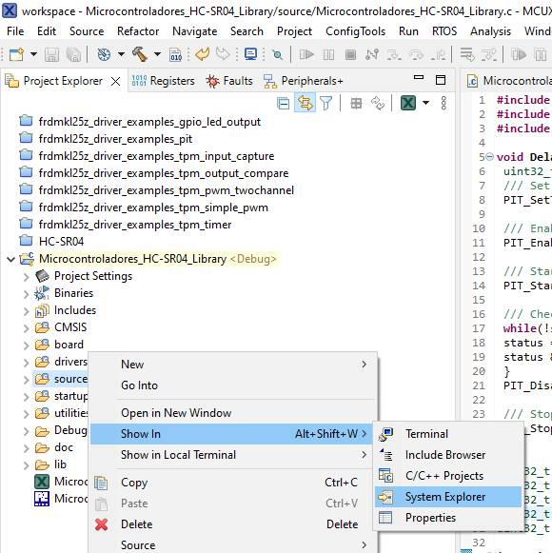
The result should look something like show in the following image.
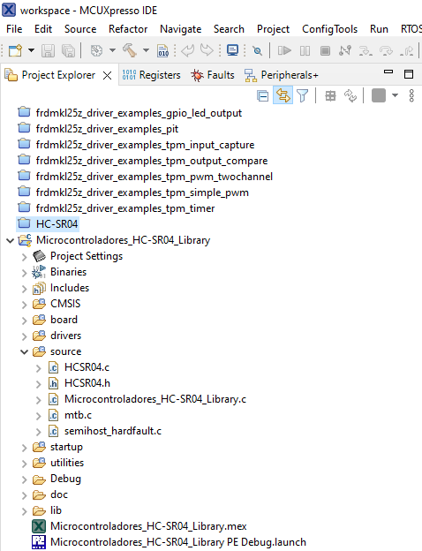
Open the source file of your main application code and include de header file (.h) of the library in your code. Then you will be able to use all the functions included in the library. An example is shown in the following image.
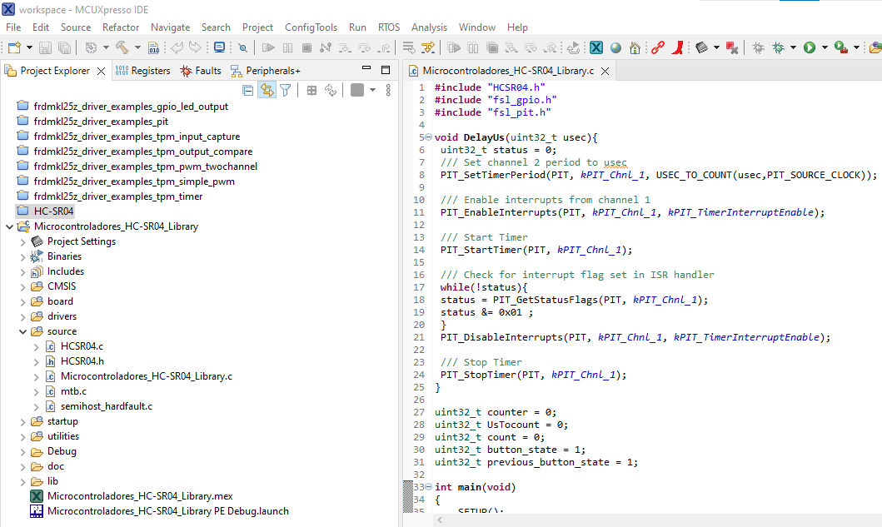

Adding a static library to your project
To use a static library in your code you need access to the library file (.a) and its header (h). Paste the header file in the source folder of your project, create a library folder called lib for example, and paste the library file inside that folder. Previously was explain how to access to your project folder from the IDE MCUExpresso. The result should look something like show in the following image.
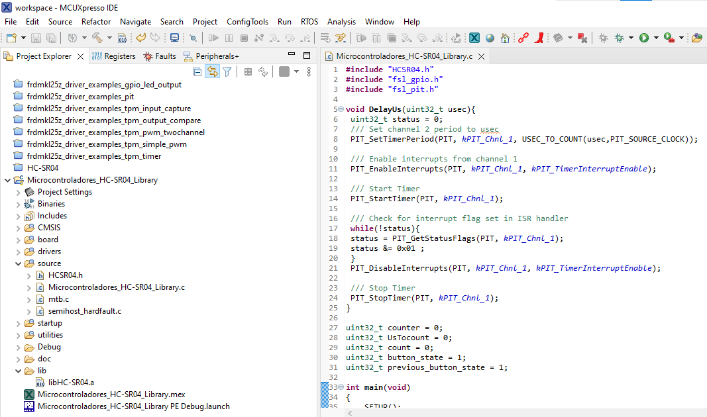
Next step is to add the library path to the linker in the properties settings. To access the properties window you should right click on the project and select the Properties option from the dropdown menu, as shown in the following image.
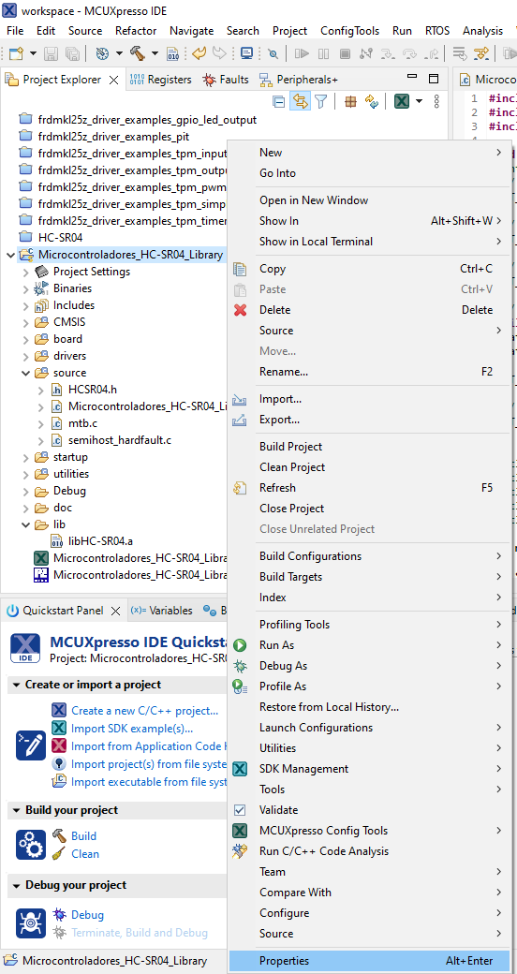
In the Properties window of the project, select C/C++ Build, then click on the Settings option, then under the MCU Linker option click on Libraries. Next add the library and the search path for the library using the add button as shown in the following image.
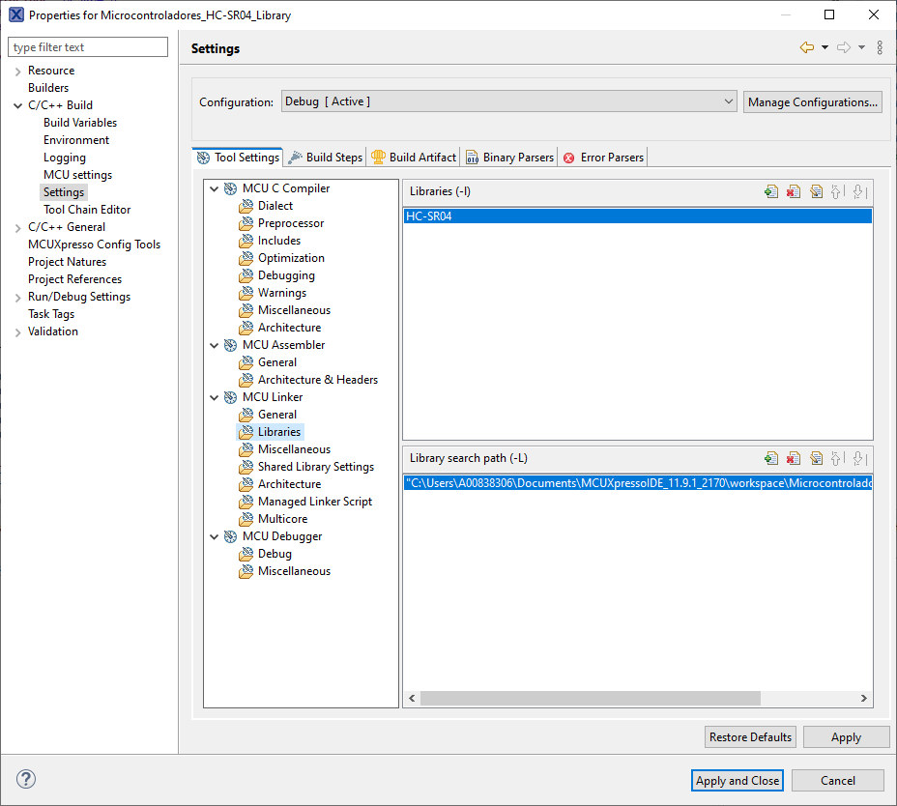

NOTE: We only specify library_name in Libraries (-l). For example, if you have a library called libHC-SR04.a, we specify HC-SR04 in the Linker Libraries settings. We also need to specify the location that we have placed the library archive in the Library search path (-L) setting.
Open the source file of your main application code and include de header file (.h) of the library in your code. Then you will be able to use all the functions included in the library, you can even debug your code and step into the functions includes on the library. An example is shown in the following image.
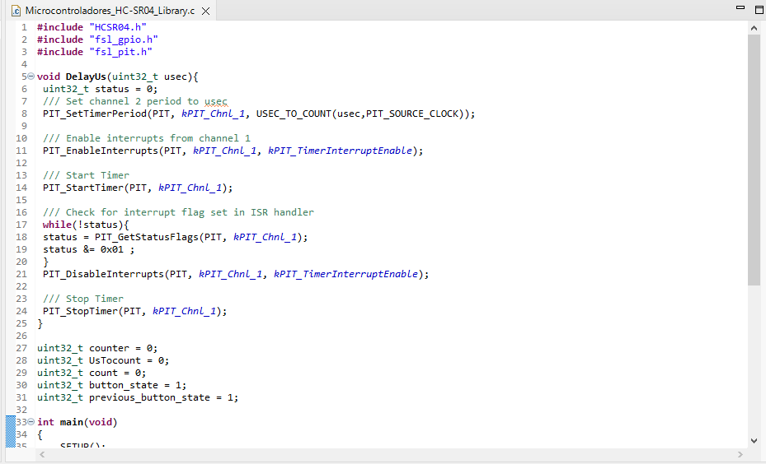

Example application
An example library was developed to illustrate the use of libraries on the MCUExpresso. The Example code is provided on the Annexes. This library enables to manage the distance ultrasonic sensor HC-SR04. It has a setup function that configures all peripherals related, and the GetDataStart function, that send the command to start the conversion to the sensor, reads the value send back by the sensor, and report the distance in cm via a serial port. Serial port is configured as follows: 115200 baud rate, 8 data bits, no parity, one stop bit and no flow control. The library uses the periodic interrupt timer (pit) to generate precise time intervals and the TPM module, to compute the length of the pulse send in response by the HC-SR04. The pin used to start the conversion of the sensor is the PTC7 or pin 1 of the J1 connector in the FRDM-KL25Z board and the pin used to measure the response is the TPM1_CH0 or pin 2 of J10 connector. The example uses the library to measure the distance each time an external button connected to the PTA5 or pin 12 of the J1 connector is pushed.

Annexes

Other Resources
You can find a guide for the process of compiling and using your own static library in MCUExpresso in the following link: https://community.nxp.com/pwmxy87654/attachments/pwmxy87654/mcuxpresso-ide%40tkb/478/1/How%20to%20create%20and%20use%20static%20library%20in%20MCUXpresso%20IDE%20-%20ver3.pdf

Example application code

HCSR04.h
/*
* Example Library to interface the HC-SR04 proximity sensor with MCUExpresso
*/
#ifndef _HCSR04_H_
#define _HCSR04_H_
#include "fsl_debug_console.h"
/*******************************************************************************
* Definitions
******************************************************************************/
#define DEMO_TPM_BASEADDR TPM1

/* TPM channel used for input capture */
#define BOARD_TPM_INPUT_CAPTURE_CHANNEL kTPM_Chnl_0

/* Interrupt number and interrupt handler for the TPM instance used */
#define TPM_INTERRUPT_NUMBER TPM1_IRQn
#define TPM_INPUT_CAPTURE_HANDLER TPM1_IRQHandler

/* Interrupt to enable and flag to read; depends on the TPM channel used */
#define TPM_CHANNEL_INTERRUPT_ENABLE kTPM_Chnl0InterruptEnable
#define TPM_CHANNEL_FLAG kTPM_Chnl0Flag

#define PIT_LED_HANDLER PIT_IRQHandler
#define PIT_IRQ_ID PIT_IRQn
/* Get source clock for PIT driver */
#define PIT_SOURCE_CLOCK CLOCK_GetFreq(kCLOCK_BusClk)
// #define LED_INIT() LED_RED_INIT(LOGIC_LED_ON)
// #define LED_TOGGLE() LED_RED_TOGGLE()

/*******************************************************************************
* Prototypes
******************************************************************************/
extern void TPM_INPUT_CAPTURE_HANDLER(void);
extern void PIT_LED_HANDLER(void);
extern void SETUP(void);
extern void GetDataStart(void);

#endif

HCSR04.c
#include "fsl_debug_console.h"
#include "board.h"
#include "fsl_tpm.h"
#include "fsl_pit.h"
#include "pin_mux.h"
#include "clock_config.h"

#include "HCSR04.h"

/*******************************************************************************
* Variables
******************************************************************************/
uint32_t captureVal = 0;
uint32_t InitialVal = 0;
uint32_t FinalVal = 0;
uint32_t ElapsedVal = 0;
uint32_t ComputedDistanceCm = 0;

tpm_input_capture_edge_t capture_mode = kTPM_RisingEdge;

extern uint32_t counter;
extern uint32_t UsTocount;

/*******************************************************************************
* Code
******************************************************************************/
void TPM_INPUT_CAPTURE_HANDLER(void)
{
captureVal = DEMO_TPM_BASEADDR->CONTROLS[BOARD_TPM_INPUT_CAPTURE_CHANNEL].CnV;

if(capture_mode == kTPM_RisingEdge)
{
InitialVal = captureVal;
capture_mode = kTPM_FallingEdge;
TPM_SetupInputCapture(DEMO_TPM_BASEADDR, BOARD_TPM_INPUT_CAPTURE_CHANNEL, capture_mode);
}
else
{
FinalVal = captureVal;
if(FinalVal < InitialVal)
{
ElapsedVal = (0xffff - InitialVal) + FinalVal;
}
else
{
ElapsedVal = FinalVal - InitialVal;
}

capture_mode = kTPM_RisingEdge;
TPM_SetupInputCapture(DEMO_TPM_BASEADDR, BOARD_TPM_INPUT_CAPTURE_CHANNEL, capture_mode);

ComputedDistanceCm = (float)ElapsedVal*(1.0/48.0)/29.0/2.0;
PRINTF("\r\nDistance in cm: %d\r\n", ComputedDistanceCm);

/* Enable channel interrupt when the second edge is detected */
TPM_DisableInterrupts(DEMO_TPM_BASEADDR, TPM_CHANNEL_INTERRUPT_ENABLE);

/* Enable at the NVIC */
DisableIRQ(TPM_INTERRUPT_NUMBER);

TPM_StopTimer(DEMO_TPM_BASEADDR);

}

/* Clear interrupt flag.*/
TPM_ClearStatusFlags(DEMO_TPM_BASEADDR, TPM_CHANNEL_FLAG);
}

void PIT_LED_HANDLER(void)
{
GPIO_ClearPinsOutput(GPIOC, (1U << 7U));
PIT_StopTimer(PIT, kPIT_Chnl_0);

/* Enable timer interrupts for channel 0 */
PIT_DisableInterrupts(PIT, kPIT_Chnl_0, kPIT_TimerInterruptEnable);

/* Enable at the NVIC */
DisableIRQ(PIT_IRQ_ID);

/* Enable channel interrupt when the second edge is detected */
TPM_EnableInterrupts(DEMO_TPM_BASEADDR, TPM_CHANNEL_INTERRUPT_ENABLE);

/* Enable at the NVIC */
EnableIRQ(TPM_INTERRUPT_NUMBER);

capture_mode = kTPM_RisingEdge;
TPM_SetupInputCapture(DEMO_TPM_BASEADDR, BOARD_TPM_INPUT_CAPTURE_CHANNEL, capture_mode);
TPM_StartTimer(DEMO_TPM_BASEADDR, kTPM_SystemClock);

/* Clear interrupt flag.*/
PIT_ClearStatusFlags(PIT, kPIT_Chnl_0, kPIT_TimerFlag);

counter ++;
}

void SETUP(void)
{
//Pulse Detect init code
tpm_config_t tpmInfo;

/* Board pin, clock, debug console init */
BOARD_InitPins();
BOARD_BootClockRUN();
BOARD_InitDebugConsole();

/* Select the clock source for the TPM counter as kCLOCK_PllFllSelClk */
CLOCK_SetTpmClock(1U);

TPM_GetDefaultConfig(&tpmInfo);
/* Initialize TPM module */
TPM_Init(DEMO_TPM_BASEADDR, &tpmInfo);

/* Setup input capture on a TPM channel */
capture_mode = kTPM_RisingEdge;
TPM_SetupInputCapture(DEMO_TPM_BASEADDR, BOARD_TPM_INPUT_CAPTURE_CHANNEL, capture_mode);

/* Set the timer to be in free-running mode */
DEMO_TPM_BASEADDR->MOD = 0xFFFF;

pit_config_t pitConfig;
PIT_GetDefaultConfig(&pitConfig);

/* Init pit module */
PIT_Init(PIT, &pitConfig);

GPIO_ClearPinsOutput(GPIOC, (1U << 7U));
}

void GetDataStart(void)
{
GPIO_SetPinsOutput(GPIOC, (1U << 7U));
PIT_SetTimerPeriod(PIT, kPIT_Chnl_0, USEC_TO_COUNT(10, PIT_SOURCE_CLOCK));

/* Enable timer interrupts for channel 0 */
PIT_EnableInterrupts(PIT, kPIT_Chnl_0, kPIT_TimerInterruptEnable);
/* Enable at the NVIC */
EnableIRQ(PIT_IRQ_ID);

PIT_StartTimer(PIT, kPIT_Chnl_0);
}

Main app code
#include "HCSR04.h"
#include "fsl_gpio.h"
#include "fsl_pit.h"

void DelayUs(uint32_t usec){
uint32_t status = 0;
/// Set channel 2 period to usec
PIT_SetTimerPeriod(PIT, kPIT_Chnl_1, USEC_TO_COUNT(usec,PIT_SOURCE_CLOCK));

/// Enable interrupts from channel 1
PIT_EnableInterrupts(PIT, kPIT_Chnl_1, kPIT_TimerInterruptEnable);

/// Start Timer
PIT_StartTimer(PIT, kPIT_Chnl_1);

/// Check for interrupt flag set in ISR handler
while(!status){
status = PIT_GetStatusFlags(PIT, kPIT_Chnl_1);
status &= 0x01 ;
}
PIT_DisableInterrupts(PIT, kPIT_Chnl_1, kPIT_TimerInterruptEnable);

/// Stop Timer
PIT_StopTimer(PIT, kPIT_Chnl_1);
}

uint32_t counter = 0;
uint32_t UsTocount = 0;
uint32_t count = 0;
uint32_t button_state = 1;
uint32_t previous_button_state = 1;

int main(void)
{
SETUP();
PRINTF("Setup Finished.\r\n");
while (count == 0)
{
button_state = GPIO_ReadPinInput(GPIOA, 5);
if(button_state == 0)
{
DelayUs(100000);
previous_button_state = button_state;
continue;
}

if(button_state != previous_button_state)
{
DelayUs(100000);
GetDataStart();
previous_button_state = button_state;
}
}
}

